1.11.2-CD CandidateRecommender Class Diagram

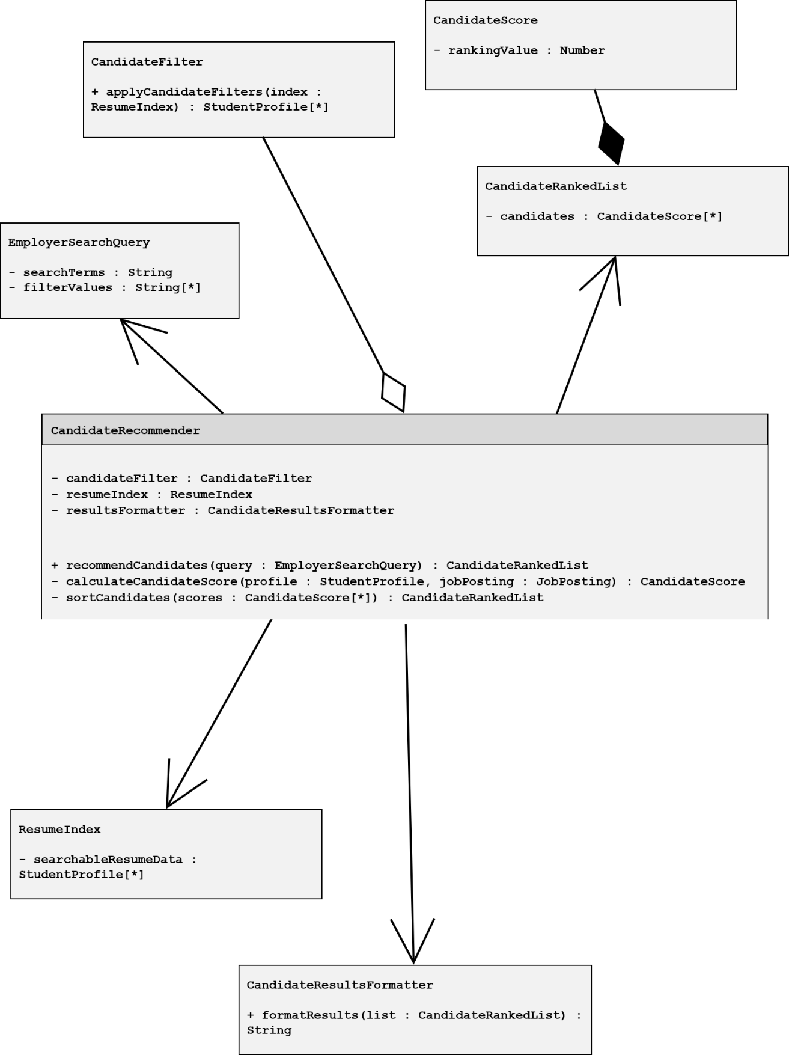

1.11.2-CD CandidateFilter Class Diagram

